Purston Infant School - Foundation Stage – Crocodiles – Remote Learning Spring 2 Week 2
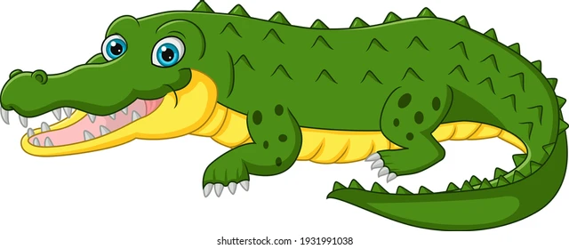
We begin this week by reading the story ‘Man On The Moon’. There is a link below for you to watch the adventure!

https://www.youtube.com/watch?v=Rt5zQ1UO6rE

Can you discuss with your child where they think the moon is? How would Bob get to the moon?

Can you draw pictures of what Bob would need to take with him to the moon?

Can you design a new alien friend for our classroom? What will you call him?

Can your child have a go at painting or drawing an alien?

Have a go at learning the song 5 little man in a flying saucer.

https://www.youtube.com/watch?v=2E3p_51tJx0

Can you have a go at making your own spaceship. There are some ideas below.

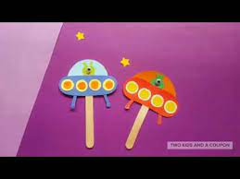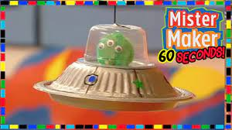

If you have some playdough at home, please have a go at following the actions on the link below. This helps your child with their fine motor skills.
https://www.youtube.com/watch?v=o9D5lfqZF3o

Please take photographs of any work your child completes and upload it onto class dojo, we would love to share this with the rest of the class!
Have fun and take care
Mrs Tonkinson

