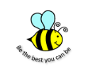
Purston Infant School
Curriculum Overview – Year 1 - Autumn 1 – Colourful Me
Enrichment Day – Friday 1st October
Literacy |  | Maths |  |  | Word of the Week – Key Vocabulary
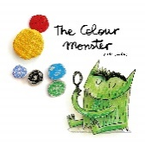  In our Literacy lessons we are going to be using stories to help us with our writing.  Children will be taught to:  - leave spaces between words.  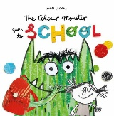  - joining words and joining clauses using ‘and’.  - begin to punctuate sentences using a capital letter and a full stop.  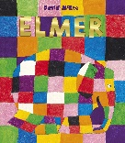  - use a capital letter for names of people, places, the days of the week, and the personal pronoun ‘I’.  - spell words containing each of the 40+ phonemes already taught. | Tricky Words  I  you  to  go  the  no  into  he  she  we  me  be  was  they  all  are  my  her | In our Maths lessons we are going to be focusing on fluency and trying to improve our understanding of numbers.  Children will be taught to:  - Count to ten, forwards and backwards beginning with 0 or 1, or from any given number.  - Count, read and write numbers to 10 in numerals and words  - To identify and represent numbers using objects and pictorial representations  - Given a number, identify 1 more or 1 less  - Count in multiples of 2.  - Represent and use number bonds and related subtraction facts (within 10)  - Add and subtract 1 digit numbers to 10 including zero  - Read, write and interpret mathematical statements involving +, - and =. |  |  | investigation  senses  unique  distance  stupendous
Home Learning  Listen to your child read 3 times a week.  Practise tricky words with them. |  | Home Learning  Count forwards and backwards from different number.  Counting objects carefully.
History | Art and Design |  | Computing | RE
We are going to be learning about changes within our living memory.  This will focus on how we have changed since we were born. | We are going to find out about two artists this half term, Picasso and Andy Goldsworthy.  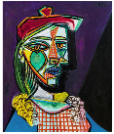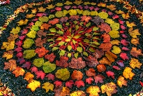 |  | We are going to look at how we use the internet and online safety. We will learn the importance of our personal information and how we can keep this private. | What does it mean to belong to a faith community?
Home Learning  Talk to someone older in your family, what toys did they have when they were younger? | Home Learning  Can you draw a portrait of someone in your family? |  | Home Learning  Ask a grown-up to show you how they use the internet. | Home Learning  Draw you and your family doing something you love together.
RSE/PSHE | Our repeated texts
What is the same and different about us?  We will be linking this to our Science topic of humans and looking at how we are like our friends and families, but also how some people are different. | 