Year 1 Science – Animals including Humans
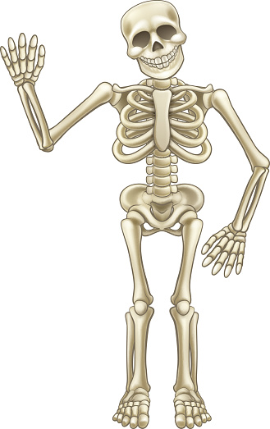
Skeleton
Topic Intent | As a scientist I will be able to:
Pupils will identify, name, draw and label the basic parts of the human body and say which part of the body is associated with each sense. | - Name the parts of my body.  - Name the features of my face.  - Name the five senses.  - Explain the importance of looking after my teeth.  - Describe how my body has changed since birth.  - Identify simple patterns in data.
Parts of the body
Key Vocabulary
sight | Your eyes let you see all the things around you.
hearing | Your ears let you listen to all the things around you. Your brain is able to tell what different sounds are.
touch | Your skin gives you the sense of touch. You can tell if something is warm, cold, smooth or rough without even looking at it!
taste | Your skin gives you the sense of touch. You can tell if something is warm, cold, smooth or rough without even looking at it!
smell | You smell using your nose. Your nose can tell if things smell nice or not nice.

Homework Links and Ideas
https://stormedapps.co.uk/pairing/pairing.html
Go on a senses walk around your house or local area. What can you see? Hear? Touch? Taste? Smell?

