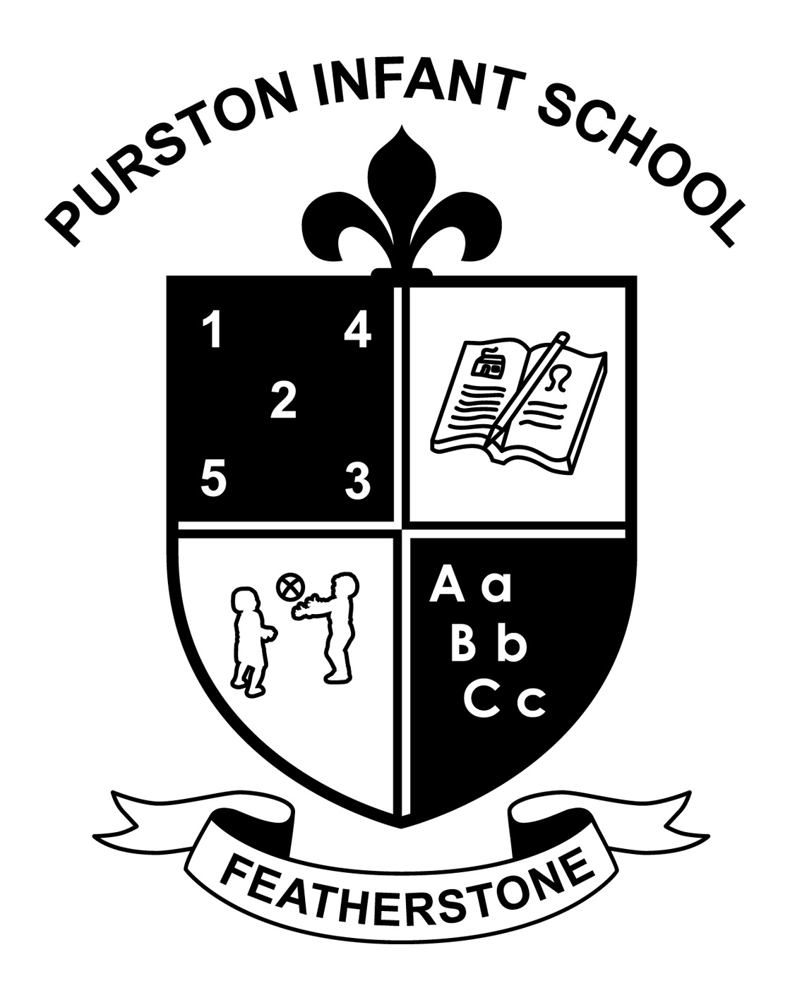

Science Policy

All children have a natural curiosity about their world from an early age. They want to explore and investigate and when their communication skills develop, to talk about their discoveries. They will enter school with some or little understanding of their world and at Purston Infants we aim to build on children’s existing knowledge and offer challenges which will allow them to further develop knowledge, communication, and practical skills in order that they can make sense of the world around them. A great deal of emphasis is placed on teaching science through first hand and practical experiences so that children are instrumental in developing and controlling their own learning thus scientific enquiry is a thread which is evident throughout all other scientific areas.

Aims and objectives
Science teaches an understanding of natural phenomena. It aims to stimulate a child’s curiosity in finding out why things happen in the way they do. It teaches methods of enquiry and investigation to stimulate creative thought. Children learn to ask scientific questions and begin to appreciate the way science will affect their future.
.
The aims of science are to enable children to:

- Develop scientific knowledge and conceptual understanding through specific disciplines of biology, chemistry and physics.
- Develop understanding of the nature, processes and methods of science through different types of science enquires that help children to answer scientific questions about the world around them.
- Be equipped with the scientific knowledge required to understand the uses and implications of science, today and for the future.

Teaching and learning style
At Purston we use a variety of teaching and learning styles in science lessons. Our principal aim is to develop children’s knowledge, skills, and understanding. Sometimes we do this through whole-class teaching, while at other times we engage the children in an enquiry-based research activity. We encourage the children to ask, as well as answer, scientific questions. They have the opportunity to use a variety of data, such as graphs, pictures, and photographs. They use ICT in science lessons where it enhances their learning. They take part in discussions and they present reports to the rest of the class. A great deal of emphasis is placed on ‘first hand’ experiences, making science meaningful and fun. Thus the children engage in a wide variety of practical enquiry based activities.

We recognise that there are children of widely different scientific abilities in all classes; therefore, we ensure that we provide suitable learning opportunities for all children by matching the challenge of the task to the ability of the child. We achieve this in a variety of ways by:
- setting common tasks which are open-ended and can have a variety of responses;
- setting tasks of increasing difficulty
- grouping children by ability in the room and setting different tasks for each ability group;
- providing resources of different complexity, matched to the ability of the child;
- using classroom assistants to support the work of individual children or groups of children.

Science Curriculum Planning

Key Stage 1
We use the National Curriculum for science as the basis of our planning. We carry out our curriculum planning in science in three phases (long-term, medium-term and short-term/on weekly planning). The long-term plan maps the scientific topics studied in each term during the key stage.

Our medium-term plans give details of the programmes of study. These plans can be found in the staff shared planning file.

The class teacher is responsible for the short term planning where the weekly lesson plans are written. These plans list the specific learning objectives of each lesson. The class teacher keeps these individual plans readily available in their classrooms.

At Purston we plan the topics in science so that they reinforce and extend prior learning. We ensure that there are opportunities for children of all abilities to develop their skills and knowledge in each unit. Continuity and progression are built into the science scheme of work so that the children are increasingly challenged as they move through the school.

Foundation Stage
At Purston we teach science in the Foundation Stage as an integral part of the topic
Work covered during the year. We relate the scientific aspects of the children’s work to ‘Understanding the World’ detailed in the document ‘Development Matters’, which underpins the curriculum planning for children aged three to five. Science makes a significant contribution to the ELGs of developing a child’s knowledge and understanding of the world. Scientific learning experiences are provided for through investigative and exploratory activities, both indoors and outdoors.

Other Curriculum Areas

English
Science contributes significantly to the teaching of English in our school by actively promoting the skills of reading, writing, speaking and listening. Some of the texts that the children study are of a scientific nature. The children develop oral skills in science lessons through discussions and through recounting their observations of scientific investigations. They develop their writing skills through writing reports and by recording information.

Mathematics
Science contributes to the teaching of mathematics in a number of ways. The children use weights and measures and learn to use and apply number. Through working on investigations they learn to estimate and predict. They develop the skills of accurate observation and recording of events. They use data to answer questions and draw conclusions.

Spiritual, Moral, Social and Cultural Development
Science teaching offers children many opportunities to examine some of the fundamental questions in life. Through many of the amazing processes that affect living things, children develop a sense of awe and wonder regarding the nature of our world.
Science raises many social and moral questions. Through the teaching of science, children have the opportunity to discuss and question moral issues. We give them the chance to reflect on the way people care for the planet and how science can contribute to the way we manage the earth’s resources. Science teaches children about the reasons why people are different and, by developing the children’s knowledge and understanding of physical and environmental factors, it promotes respect for other people.

Visits and Visitors
At Purston Infant School great value is placed on outside visits, whether it be in the local environment or further afield. The visits are designed to contain a wealth of stimulating material linked with the topic being covered or a specific curriculum area.
Children are encouraged to observe, ask questions and record their visit in a variety of ways. Work in the classroom can be reinforced by the visit or it can be a starting point.

SEND
At Purston we teach science to all children, whatever their ability. Science forms part of the school curriculum policy to provide a broad and balanced education for all children. We provide learning opportunities that are matched to the needs of children with learning difficulties. Our work in science takes into account the targets set in the children’s one page profile and we provide additional support where needed.

Assessment and Recording
In Key Stage 1 we assess children’s work in science by making informal judgements as we observe them during lessons. On completion of a piece of work, the teacher marks the work and comments as necessary. At the end of a unit of work s/he makes a summary judgement about the work of each pupil in relation to the National Curriculum.
This is then used to make a formal judgement and saved on O’Track.
Teachers make an assessment of the children’s work in science at the end of Key Stage1. We report teacher assessment results to parents at the end of the year and forward the information to the LA.

In the early years we assess children against the Early Learning Goals, this informs the Early Years Profile.

Resources
We have sufficient resources for all science teaching units in the school. We keep these in a central store where there is a box of equipment for each unit of work.
The library contains a good supply of science topic books to support children’s individual research.

Monitoring and review
It is the responsibility of the science leader to monitor the standards of children’s work and the quality of teaching in science. The science subject leader is also responsible for supporting colleagues in the teaching of science, for being informed about current developments in the subject and for providing a strategic lead and direction for the subject in the school. The science subject leader gives the head teacher an annual summary report in which s/he evaluates strengths and weaknesses in the subject and indicates areas for further improvement. The science leader has specially allocated time for fulfilling the vital task of reviewing samples of children’s work and visiting classes to observe teaching in the subject.

Health and Safety
At Purston we try to maintain high safety standards. Risk assessments are carried out for outside visits- see policy for outside visits. The programme of study of scientific enquiry promotes investigation and exploration in science. In their planning of practical activities teachers need to anticipate likely safety issues. They should also explain the reasons for safety measures and discuss any implication to children. Children should always be encouraged to consider safety when they plan and carry out an investigation and when working with each other see Health and Safety Policy for further details.

