
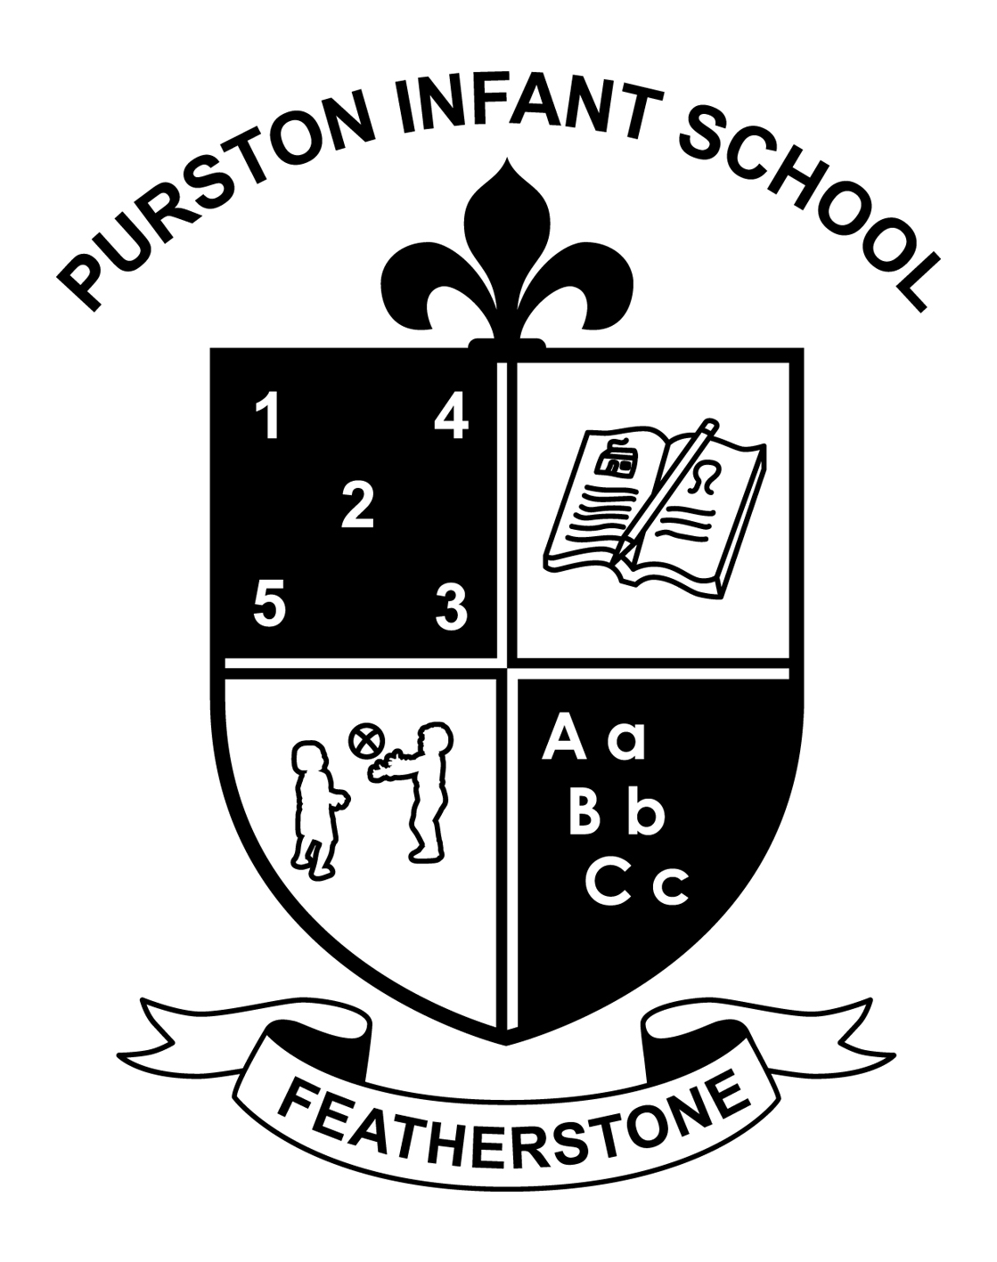
PURSTON INFANT SCHOOL
Nunn’s Lane, Featherstone
Tel: 01977 704344
www.purstoninfants.co.uk

19th March 2020

Dear Parents/Carers

School closure from Monday 23rd March until further notice
After our Prime Minister’s announcement, the directive is for our school to close at 3.30pm on Friday 20th March until further notice. We are however going to run a skeletal service for children of key workers and certain vulnerable children.
The Government have set out guidance to allow a small number of children to still attend and we will be adhering very carefully to this guidance. This will allow key staff who have no potential childcare solutions, with roles in society that make a significant difference at this difficult and unprecedented time, to continue to carry out their vital roles. This guidance is to be published today and will be shared accordingly with all families as soon as possible. If parents feel that they can and will keep children away from school despite featuring in the guidance, we assume that this is acceptable as the aim of the ‘closure’ is to minimise the risk of spreading infection for all pupils and staff.
Official guidance from Department for Education announcement: It is clear that education and children’s social care settings are increasingly finding it difficult to continue as normal, as illness and self-isolation impacts on staffing levels and pupil attendance. To provide parents, students and staff with the certainty they need we are announcing that schools, colleges and early years settings will be closed to everyone except children of key workers and vulnerable children from Monday, as part of the country’s ongoing response to coronavirus.
Examples of these workers include NHS staff, police and delivery drivers who need to be able to go to work. Vulnerable children include those who have a social worker and those with Education, Health and Care Plans.
A full list of key worker categories will be published by the Cabinet Office later today.
Children who do not fall into these groups should remain at home with appropriate care.
If you fall into these categories, I am asking that you complete the form below urgently so that we can carry out planning for our provision. It is important that you complete a form for each child, if you intend on taking up a place on Monday 23rd March.
To be clear, school will only be open from Monday 23rd March, to children of key workers (comprehensive list to follow) and children that have a social worker and those with Education, Health and Care Plans.
Kind regards
P Barnett

Skeletal school eligibility form
Your child’s name
Are you a single parent / main carer key worker? | Yes No
If yes to above, what is your job?

Are both parents / main carers in the household key workers? | Yes No
If yes to above, what are your jobs?

Can you please provide evidence of this in terms of a recent wage slip (last two months) or current photo ID badge or letter from your employer? | Evidence seen by:  Signed
Does your child have an EHCP?

Does your child have an allocated Social Worker?

We will send by parentmail a comprehensive list of key workers once we have this.
Many thanks for your support at this time.
Please return back to school later today or at the latest by 9am on Friday 20th March 2020.

