Our School Uniform
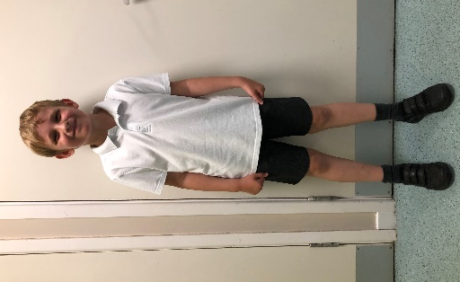
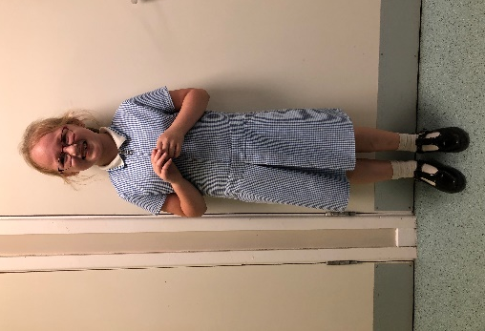
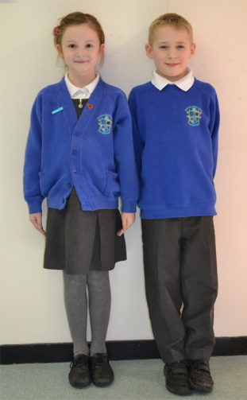

Our uniform consists of a white polo shirt, grey trousers or skirt, with a royal blue jumper or cardigan. In summer, pupils may wear a blue checked dress or grey shorts.
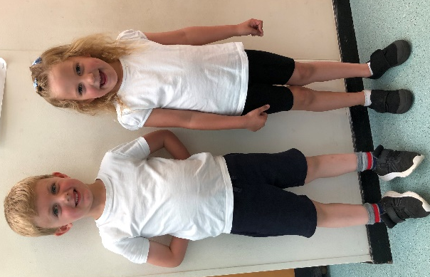

PE Kit (Indoor)
Indoor kit boys – close fitting black/navy shorts and a plain white t-shirt
Indoor kit girls – black/navy leotard or black/navy close fitting shorts and a plain white t-shirt
Pumps or trainers are needed for indoor PE – no bare feet
PE Kit (Outdoor)
Outdoor kit (Boys & girls) – Black/Navy Tracksuit, plain white t-shirt and trainers.

